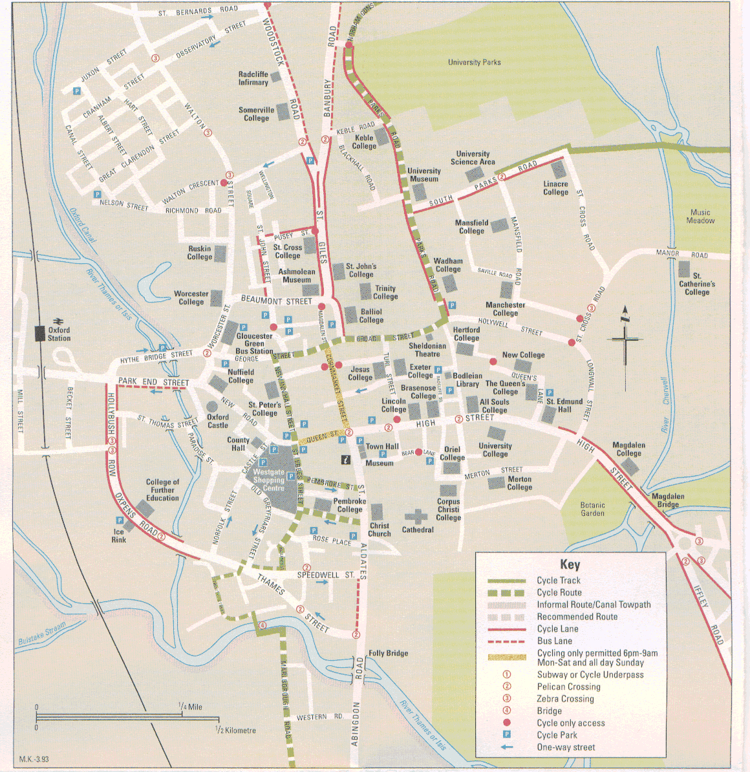
Little Clarendon Street
Taylor Institute
Sainsbury’s
(Sandwiches)
Felson’s
(Sandwiches)
Christ Church
Meadow
Lunchtime
walk
Taylor’s
(Sandwiches)
Phonetics Lab
French patisserie

