IViE

Intonational Variation in English

Speech data from the IViE corpus

Esther Grabe, Brechtje Post and Francis Nolan

Department of Linguistics, University of Cambridge
Cambridge CB3 9DA

Contents of the IViE Corpus on CD-ROM

NB: this booklet was written for the CD-ROM version of the corpus; hence the reference to CDs.

CD1 Speech data from Belfast (259MB) + information files: Intro (information about IViE), Stimuli, Filename (key to the file names), Filelist, Map1 and Map2 (used in Map Task)
CD2 Speech data from Bradford (273MB) and Cambridge (299MB)
CD3 Speech data from Cardiff (280MB) and Leeds (300MB)
CD4 Speech data from Liverpool (217MB) and London (321MB)
CD5 Speech data from Malahide (286MB) and Newcastle (243MB)

Names of directories containing speech data:
../Belfast ../Cardiff ../LondonWI
../BradPunj ../Leeds ../Malahide
../Cambr ../Liverpl ../Newcastl

For each variety, the CDs contain 5 subdirectories corresponding to the 5 speaking styles we recorded:
../free , ../map , ../retold, ../passage, and ../sentence

See the text file Contents.txt for further information.

Introduction

This set of CDs contains speech data from the IViE project in MS RIFF WAVE format (approximately 36 hours of speech). The data allow for cross-varietal and cross-stylistic comparisons of a subset of the prosodic systems found in the British Isles. You can listen to the data in any speech processing package which supports .wav files (e.g. Praat, xwaves, PitchWorks, Wavesurfer ...).

This booklet contains information about
- the varieties of British English recorded on the CDs (p2)
- the speaking styles in IViE (pp3-4)
- a key to the file names of the speech files (pp5–9)
- a table of contents of the CDs (p10)
This information can also be found on CD1. For a complete list of the speech files on these CDs, and for the stimuli that were used to elicit the data, please consult the files Filelist.txt and Stimuli.txt on CD1.

1

Varieties of English in the IViE Corpus

- Belfast
- Bradford (bilingual Punjabi-English speakers)
- Cambridge
- Cardiff (bilingual Welsh-English speakers)
- Leeds
- Liverpool
- London (speakers of Jamaican descent)
- Dublin (Malahide)
- Newcastle

The data were collected in urban secondary schools, and the speakers were about sixteen years old at the time of recording. Twelve to fourteen speakers were chosen from each variety (half male, half female) and all speakers took part in the same set of tasks.

2

2

Speaking styles

The tasks were designed to elicit comparable data in five speaking styles:

- Conversations. Topic: smoking.

- Goal directed interactions: An adaptation of the Map task ("find your way around a small town"). The Instruction Giver’s Map is given on the following page; for the Instruction Follower’s Map see the file Map2.doc or Map2.gif on CD1.

- Story telling from memory: The fairy tale Cinderella.

- A read passage of speech: Cinderella (see Stimuli.txt on CD1).

- Phonetically controlled sentences. A variety of grammatical structures: statements, questions without morphosyntactic markers, WH-questions, inversion questions, coordination structures (see Stimuli.txt on CD1).

3

3

3

Instruction Giver’s map used in the Map Task

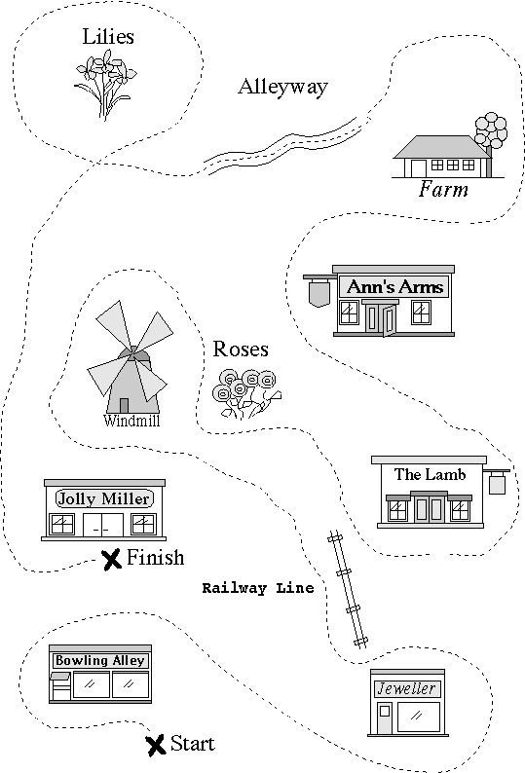
4

Key to the file names

The first letter of the file name indicates the task type (speaking style):
'f' = free conversation
'm' = map task
e.g. p5wxy.wav 'r' = retold version of read passage
'p' = read passage

For the controlled sentences:
's' = statement
'q' = question
'w' = WH-question
'i' = inversion
'c' = coordination

The following number shows which section of the task was produced:
- free conversation: the number of one-minute files varies – it depends on the length of the conversation
- map task: m1 to m8
- retold: r1 to r6
- passage: p1 to p5 e.g. p5wxy.wav
- controlled sentences: s1 to s8, q1 to q3, w1 to w3, i1 to i3, c1 to c5

5

An overview of the speech data covered by each section is given on p9. Note that whenever the speaker took more than 60 seconds to produce the section in question, it was split into an a-file and a b-file (e.g. p5awxy and p5bwyz instead of p5wxy). The sections with (a) and (b) files are listed at the end of the file Filename.txt on CD1.

The next letter indicates the variety:
'b' = Belfast
'p' = Bradford Punjabi
'c' = Cambridge
'w' = Cardiff e.g. p5wxy.wav
'l' = Leeds
's' = Liverpool (Scouse)
'j' = London West-Indian (Jamaican)
'm' = Dublin (Malahide)
'n' = Newcastle

The two letters at the end of the file name are the initials of the speaker. The speakers are listed on page 7.

6

Speaker pairs

The map task and the free conversation were recorded in pairs. Here, the initials of the speaker who acted as Instruction Giver are used in the file names (the first speaker of each pair):

Belfast AM & EC, CC & RC, DH & JX, JM & RO, RG & GM, TS & DO

Bradford WA & TA, ZM & AM, RH & JK, RR & SM, GK & FM, KI & SN, RR & RA

Cambridge LH & LP, MF & HB, MA & JI, ER & SM, JE & MC, PT & TG

Cardiff NC & KV, HW & MK, HR & LD, SC & HD, XT & ER, LH & KT (i.e. sexes mixed)

Leeds JP & MD, JW & ST, KP & CM, NB & KF, RL & ML, RP & SU

Liverpool CH & RB, DS & LM, GW & PX, PH & SB, TR & LP, NT & JS (no free conversation for NT, JS and NS)

London MO & MM, KG & RA, SF & TE, MM & FM, MD & CR, KJ & JB, AH & WS

Malahide DO & DK, AO & EC, PM & AD, DH & MP, MM & KG, AB & KM

Newcastle JB & AM, RF & MC, SB & EP, JW & VW, RP & LC, SE & ML

8

Speakers

Belfast Male: GM, RG, JM, TS, DO, and RO
Female: CC, AM, EC, DH, JX, RC
Bradford Male: WA, TA, ZM, AM (no passage), RH, JK, AA (only the non-interactive tasks),
Female: RA, RR, GK, KI, SN, SM, FM
Cambridge Male: MA, JI, MC, PT, JE, TG,
Female: LP, ER, SM, LH, MF, HB
Cardiff Male: MK, HR, LD, XT, ER, LH,
Female: NC, KV, HW, SC, HD, KT
Leeds Male: JP, MD, RP, JW, ST, SU,
Female: CM, KF, NB, KP, ML, RL
Liverpool Male: GW, PX, PH, SB, NT, JS (map task only), NS (sentences, read and retold only),
Female: CH, RB, DS, LM, TR, LP
London Male: RA, KG, MM, MO, AH, WS,
Female: MD, SF, TE, CR, FM, JB, KJ
Malahide Male: DO, DK, PM, AD, DH, MP;
Female: AO, EC, MM, KG, AB, KM
Newcastle Male: AM, MC, RF, JB, SE, ML
Female: EP, RP, VW, SB, JW, LC

7

Division of speech data into sections

Free conversation: Each section contains 60 seconds of conversation.

Map task: m1 [from start] to jeweller, m2 jeweller to windmill, m3 windmill to The Lamb, m4 The Lamb to Ann's Arms, m5 Ann' Arms to Alleyway, m6 Alleyway to Lillies, m7 Lillies to [going down towards Jolly Miller], m8 [going down towards Jolly Miller] to Jolly Miller (Note: m9pfm and m10pfm contain the recap of the route which Instruction Follower GK produces after arriving at the end point).

Retold passage: r1 start story to announcement ball, r2 announcement ball to arrival fairy godmother, r3 arrival fairy godmother to Cinderella goes to ball, r4 Cinderella goes to ball to C leaves ball, r5 C leaves ball to prince arrives at Cs home, r6 prince arrives at Cs home to end story.

Read passage (see Stimuli.txt on CD1 for full text): p1: Once upon a time ... and hair spray, p2: When her sisters ... to pull the carriage., p3: Then the girl ... of this dance?', p4: Prince William ... their feet were enormous!, p5: 'Do you have ... happily ever after.

Sentences: see Stimuli.txt on CD1.

9

