Class: Statistics for Linguistics Students Dr Bettina Braun
Exercises Week3
Assignment due 01-11-2004

- The mean pause duration in a read text is 200ms with a standard deviation of 50ms. For the calculations please specify how you reached your conclusion!
  - Is this a statistic or a parameter?
If we are only interested in describing this particular read test, then it’s a parameter. If we use this text to draw inferences about pause duration in any text then it’s a statistic.
  - What proportion of the data is above 70ms?
z=2.6
0.47% of the data lie below 70ms
99.53% of the data lie above 70ms
  - What proportion of the data falls between 100ms and 300ms?
z=2
2,28% lie below 100ms and 2.28% lie above 300ms
95.44% lie between 100ms and 300ms
- If we have a sample size of 50, what does the sampling distribution of the means look like if the population is a) U-shaped, b) skewed-left, and c) normally distributed?
Because of the central limit theorem, the sampling distribution of the mean will be normally distributed, irrespective of the form of the parent distribution

- What happens, if the sample size increases for the following statistics. Does the
  - estimated mean increase, decrease, or stay approximately the same? Why?
Stays the same as the sample mean is an adequate estimate for the population mean (central limit theorem)
  - standard error increase, decrease, or stay approximately the same? Why?
Standard error decreases with the square root of the sample size (see formula for standard error)

- What are the dependent and independent variables in the following research questions? Please state the null hypothesis.
  - Does the gender influence the fundamental frequency (pitch) in adults?
- dependent variable: f0 (interval data)
- independent variable: gender (2 levels)
- null-hypothesis: there is no difference in f0 for males and females
  - Does the gender have an effect on the fundamental frequency (pitch) in children under 10?
see a)
  - Imagine you have a text-to-speech synthesis system. You are interested to find out whether the acceptability (from 1 to 5) is increased if you model short pauses at syntactic phrases.
- dependent variable: acceptability (ordinal data)
- independent variable: TTS with/without pause model (2 levels)
- Null-Hypothesis: Duration model does not influence acceptability rating
  - Is the proportion of consonants to vowels the same in English, Italian, German, and Spanish?
- dependent variable: proportion of consonants to vowels (interval, ordinal save!)
- independent variable: language (4 levels)
- null-hypothesis: The proportion is the same in all 4 languages tested
  - Subjects learned 20 nonsense-words presented visually. 30 minutes later they were tested for retention. The next day, the same subjects learned another 20 nonsense-words, this time in a combined visual and auditory presentation. Again, after 30 minutes they were tested for retention. The researcher measured the number of correct nonsense-words.
- dependent variable: number of correct responses (interval)
- independent variable: kind of presentation (2 levels)
- null hypothesis: The number of correct responses will be the same in the two conditions
  - To study the duration of words in repeated production, twenty subjects read paragraphs in which the same words appeared 4 times. Are words produced shorter if they are repeated?
- dependent variable: duration of words (interval)
- independent variable: number of occurrence (4 levels)
- null hypothesis: the duration is the same in all occurrences
  - A group of university students was given a test and depending on the responses, they were grouped into three groups of extroversion. Then they were asked to write an email to their mother, a friend and to a professor. Does extroversion correspond with the use of linguistic means. Measured are the number of exclamation marks and the sentence length.
- dependent variables: number of exclamation marks (interval) and sentence length (interval)
- independent variable: extroversion (3 levels)
- null hypothesis: extroversion does not influence linguistic means

- What is the type of dependent variable (interval, ordinal, nominal) for the above experiments? How many levels do the independent variables have in each of the research questions?

- Please fill the cells of the table with “Type I error”, “Type II error”, and “correct decision”

 | True state of affairs
 | No difference | Difference exists
Reject H0 | Type I error | Correct decision
Accept H0 | Correct decision | Type II error

- Download the dataset for week3.
  - You’ll find 3 columns of variables, the first being the year of the exam (1990 and 2000), the second the gender (starting with males), the third the score. Please name and label the variables correctly,
  - Draw the 95% confidence interval for females and males (for both exam years). Do the distributions look much different? Report the mean and the sd for female and male scores.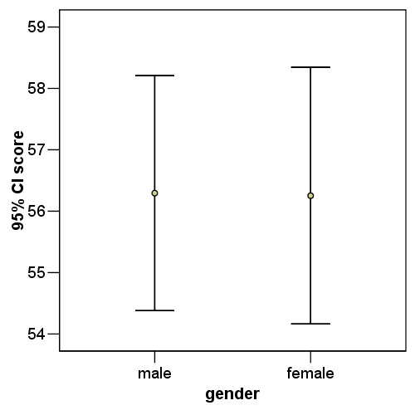

Mean (female): 56.25 sd (female): 9.8
Mean (male): 56.29 sd (male): 8.9

  - Draw the 95% confidence interval for males and females, grouped according to the exam year. Describe the distributions for the different conditions.

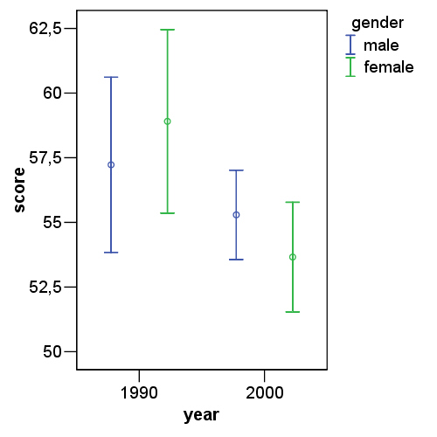

The scores were higher in 1990 than in 2000. In 1990 the male score was slightly lower than the female scores. In 2000, the male score was slightly higher than the female scores.

Please submit the assignment in electronic form, naming the file <initials>_statstut1

