Class: Statistics for Linguistics Students Dr Bettina Braun
Exercises Week 4
Assignment due 08-11-2004

- Please answer the following questions for experiments a and b.
(i) State the number of independent variables (and their levels).
(ii) State the type of dependent variable(s).
(iii) Is it a between-subjects or a within-subjects design?
(iv) Ignoring the assumptions of equal variances and normally distributed data (for the moment), can you do a t-test? If yes, is it an independent or paired t-test?
  - You have a group of 100 children with speech errors. You arbitrarily divide them into an experimental group and a control group. The experimental group receives logopaedic training for 3 month, the other group not. Both groups are shown 30 familiar items on the screen, which they had to name. The number of correct productions was counted for every subject. Did the training significantly improve the number of correctly produced words?
(i) 1 independent variable with 2 levels (with/without logopaedic training)
(ii) Dependent variable is interval
(iii) Between-subjects design since every subjects contributes to only one experimental condition
(iv) I assume the scores to be roughly normally distribution, so we can do an independent t-test
  - You want to test whether accentuation has an effect on vowel length. You have a group of words, in which the vowels /a/ and /i/ are either accented or unaccented. Overall, you have 10 unaccented and 10 accented /a/s and /i/s. 20 speakers read all the words and you build the mean duration for the stressed and unstressed vowels /a/ and /i/ for every speaker. Is there a significant difference in the duration of the vowel /a/ and /i/, depending on stress?
(i) 2 independent variables with 2 levels each (accented vs. unaccented and /a/ vs. /i/)
(ii) 1 dependent variable (interval scale)
(iii) within-subjects design since every speaker contributes to both conditions
(vi) durations are roughly normally distributed => paired t-test

- Please open the dataset rt_paired.sav.
  - See whether the basic assumptions of a parametric test are valid (hint: histogram).
From the following histograms I conclude that each of the two conditions is roughly normally distributed:

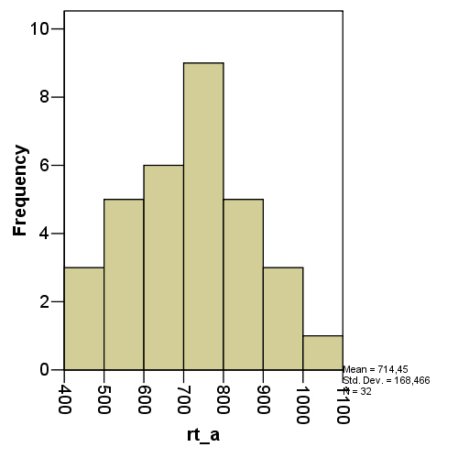 | 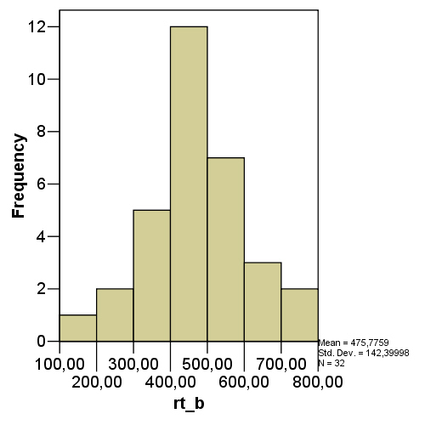

  - Is the reaction time (rt) different in the two conditions a and b? (Please state the mean difference, the t-value, the degrees of freedom, as well as the p-value in your answer!)
There is a significant effect of condition on reaction time (t=5.31, df=31, p < 0.001). Reaction time in condition a is 238ms longer than in condition b

- Now let’s assume, I organised the table incorrectly because the experiment was actually designed as a between-subjects experiment
  - Please reorder the SPSS table accordingly. Please submit the file you generated!
  - Calculate now if the reaction time (rt) is different in the two conditions a and b? (Please state the t-value, the degrees of freedom, as well as the p-value in your answer!)

Solution see ppt-slides of week 4

- Open the datafile rt_cond_c_d.sav
  - Inspect the error-bar plot on page 32 of the powerpoint presentation for week 4. Would you expect to find a significant difference in rt between conditions a and c?
No, since the 95% confidence intervals of the two means are highly overlapping
  - Judging from the histogram for condition c, can you calculate a t-test? If yes, is there a significant difference in reaction time in condition a and c, supposing the data was collected in a between-subjects experiment?

From the histogram, the rt of conditions c look roughly normally distributed, so we can calculate a t-test. There is significant difference in reaction times between conditions a and c (t=2.7, df=62, p=0.009). The reaction time in cond a is 112 ms longer than in cond c.
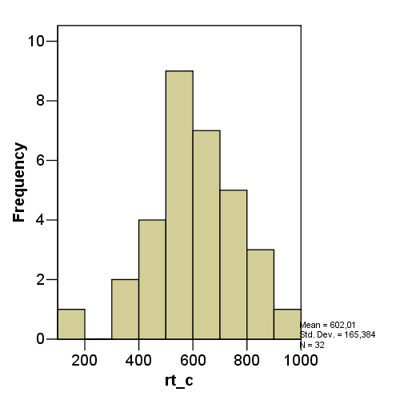

Please submit the assignment in electronic form, naming the file <initials>_statstut4 (make sure your name is found in the file as well)

