Class: Statistics for Linguistics Students Dr Bettina Braun
Exercises Week 6
Assignment due 22-11-2004

Your name:

- Check for the following data whether there is an interaction between aspect and tense-marking at the 5% level? Please report the expected frequencies per cell, the df, and the chi-square value.

Aspect | Past tense | Present tense | total
Progressive | 308 | 476 | 784
Non-progressive | 315 | 297 | 612
Total | 623 | 773 | 1396

- You want to test whether duration is used in the same way to mark prominence in French and Bulgarian. Half of the French and Bulgarian speakers have to produce sentences where your target word is accented, half the speakers sentences where your target word is unaccented. You measure the duration of the target word.
  - What experiment do you have to do to answer the question?
  - Do you have to do post-hoc tests and if yes for which variable?

- Download the dataset “durationdata.sav”
  - Please investigate the effects of accentuation and vowel type on vowel duration (Please state F-value with the degrees of freedom) and the p-value in your answer for main effects and interactions!
  - Are the variances homogenious?
  - Draw a graph of the interaction effects (either by asking for a plot in the general linear model (ANOVA) or by drawing a line plot)

- Please report the significance for the following SPSS output (main effects and interactions with F-value, degrees of freedom, and significance level). How many levels did the variables FLOUR and FAT have?

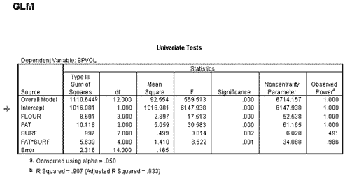

- Please indicate for the following interaction plots whether there is a significant main effect of gender, origin, and an interaction

NorthSouth
Male
Female
NorthSouth
NorthSouth
NorthSouth
NorthSouth

