Class: Statistics for Linguistics Students Dr Bettina Braun
Exercises Week 6

- Check for the following data whether there is an interaction between aspect and tense-marking at the 5% level? Please report the expected frequencies per cell, the df, and the chi-square value.

Aspect | Past tense | Present tense | total
Progressive | 308 | 476 | 784
Non-progressive | 315 | 297 | 612
Total | 623 | 773 | 1396

The expected frequencies per cell are:

Aspect | Past tense | Present tense | total
Progressive | (784*623)/1396=349.9 | (784*773)/1396=434.1 | 784
Non-progressive | (612*623)/1396=273.1 | (773*612)/1396=338.9 | 612
Total | 623 | 773 | 1396

There are 2 independent variables, so the df is (2-1)(2-1)=1
X² = Σ ((O-E)² /E) = (308-349.9)²/349.9 + (476-434.1)²/434.1 +
(315-273.1)²/273.1 + (297-338.9)² / 338.9 = 5.0 + 4.0 + 6.4 + 5.2 = 20.6
Therefore, there is a highly significant interaction between aspect and tense=marking, as X² is well above 3.84, the p-value in the table for the 5% level. The interaction is even significant at p = 0.001.

- You want to test whether duration is used in the same way to mark prominence in French and Bulgarian. Half of the French and Bulgarian speakers have to produce sentences where your target word is accented, half the speakers sentences where your target word is unaccented. You measure the duration of the target word.
a. What experiment do you have to do to answer the question?
IV = accenting, 2 levels; language, 2 levels
DV = duration, interval
We are testing the null hypothesis that the data is taken from the same population. Therefore we carry out a 2 factor between-subjects ANOVA.

- Do you have to do post-hoc tests and if yes for which variable?
No, because there are no more than 2 levels for each IV.

- Download the dataset “durationdata.sav”
  - Please investigate the effects of accentuation and vowel type on vowel duration (Please state F-value with the degrees of freedom) and the p-value in your answer for main effects and interactions!
There is a significant main effect of accentuation (F(1,236) = 1346.7 p<0.001) and of vowel type (F(1,236) = 191.6 p<0.001). There is no interaction between accentuation and vowel type (F(1,236) <1)

  - Are the variances homogenious?
Yes, Levene’s test for equality of variances gives p = 0.8, i.e. we need not reject the null-hypothesis that the variances are homogenious
  - Draw a graph of the interaction effects (either by asking for a plot in the general linear model (ANOVA) or by drawing a line plot)

- Please report the significance for the following SPSS output (main effects and interactions with F-value, degrees of freedom, and significance level). How many levels did the variables FLOUR and FAT have?

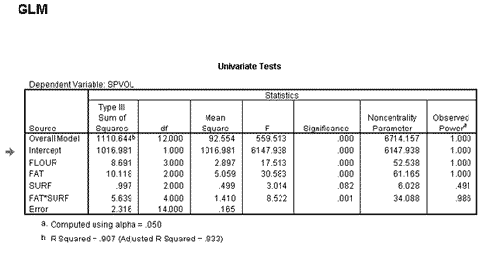

Flour: F(3,14)=17.5 p<0.001
Fat: F(2,14)=30.6 p<0.001
Surf: F(2,14)=3.0 p=0.082
Fat*Surf: F(4,14)= 8.5 p=0.01
Flour had 4 levels and fat had 3 levels (df=a-1)

- Please indicate for the following interaction plots whether there is a significant main effect of gender, origin, and an interaction

See ppt-slides of week 7

